
LS1202: Biology Laboratory II
BIOPHYSICS EXPERIMENT

ARYA BASAK
23MS233

23MS233

AIM: Estimation of diffusion coefficient from blob diffusion experiment
METHODOLOGY:
The experiment was conducted to determine the diffusion coefficient of potassium permanganate (KMnO4) in water. A 5 µL droplet of KMnO4 was carefully introduced into the center of a petri dish containing 10 mL of distilled water using a micropipette. The diffusion process was recorded using a mobile phone camera positioned directly above the dish in the support of a tipbox, ensuring stable and consistent imaging conditions. After the diffusion process was recorded, the petri dish was removed, and a measuring scale was placed in the same position to capture a calibration image, allowing for the conversion of pixel measurements to physical dimensions in millimeters. Two snapshots were extracted from the recorded video at different time intervals to analyze the diffusion. These snapshots were processed using IMAGEJ analysis software to generate intensity distribution profiles, from which the Full Width at Half Maximum (FWHM) was determined. The diffusion coefficient was then calculated using the FWHM values and the time intervals between the snapshots. Throughout the experiment, efforts were made to minimize potential sources of error, including careful calibration, controlled environmental conditions, and the use of repeated measurements to ensure accuracy.
CALCULATIONS:
- For calculating the Full Width at Half Maximum (FWHM); We need to take the maximum (max(y)) and minimum (min(y)) points in the x axis (Gray values) in the graph of profile diagram and need to take the average of max(y) and min(y) which gives us the half maximum point. Then find the close corresponding values of half maximum point in y axis (pixels) to take the full width, First in the decreasing slope (x1) and then in the increasing slope (x2). By subtracting x2 from x1 we get the value of FWHM.

- We can calculate the standard deviation(σ) of the Gaussian Probability Distribution using the Full Width at Half Maximum (FWHM) by this relation:

FWHM = 2$\sqrt{2\log_{e}{2}}× σ$ = 2.355 $×σ$
- Then we can find the Diffusion coefficient of KMnO4 using the following relation:
$$D=\frac{σ_{2}^{2}-σ_{1}^{2}}{6\left(t_{2}-t_{1}\right)}$$

OBSERVATIONS:
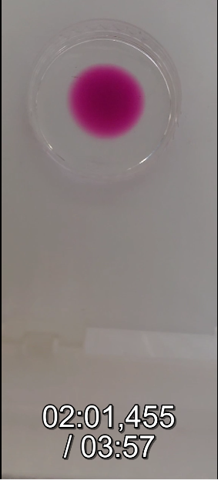
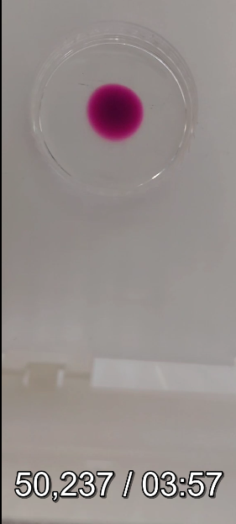
- FIRST PAIR OF SNAPSHOTS

- SECOND PAIR OF SNAPSHOTS
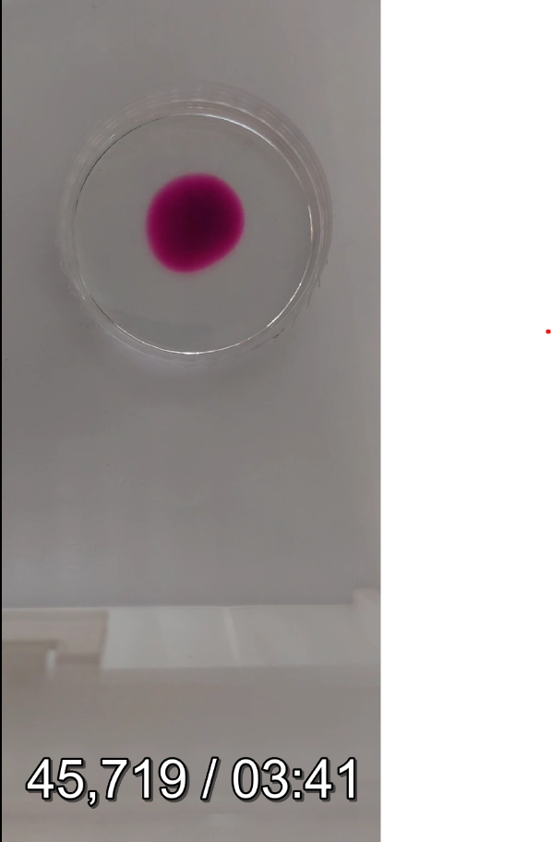

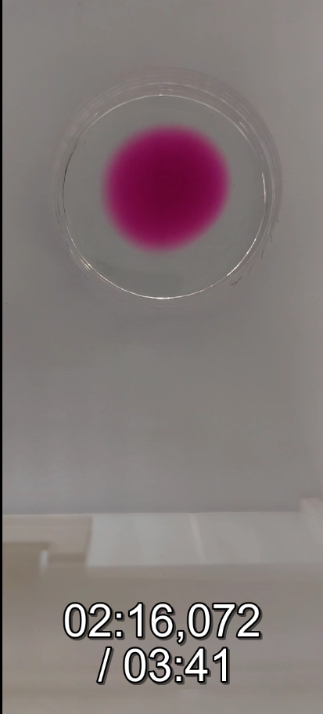
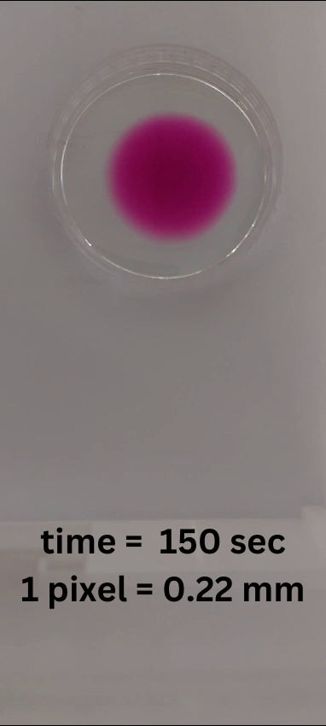
- THIRD PAIR OF SNAPSHOTS
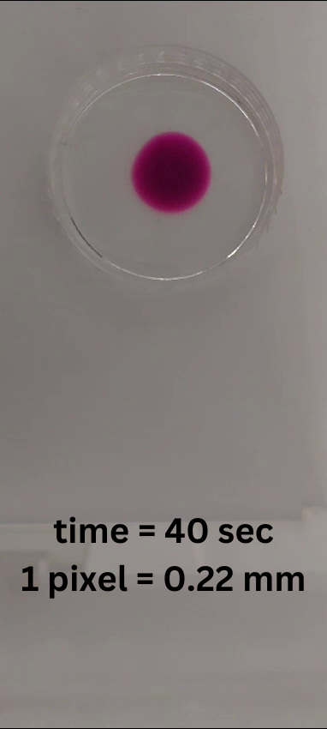

- SCALE FOR CALIBRATION
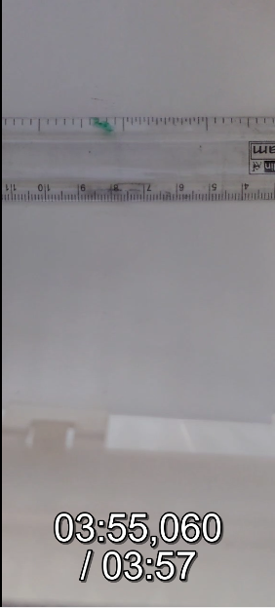

ESTIMATIONS:

 | t1 | t2 | t2-t1 | FWHM t1 (pixels) | FWHM t2(pixels) | pixel in mm | sig1sq | sig2sq | sig2sq-sig1sq (pixel2) | D (mm2/sec) | D (10^-9 m2/sec)
x-scan1 | 50.237 | 121.455 | 71.218 | 45 | 60 | 0.303 | 365.126 | 649.114 | 283.987 | 0.20137 | 201.373
x-scan2 | 40.441 | 150.542 | 110.101 | 70 | 96 | 0.303 | 883.516 | 1661.73 | 778.215 | 0.35694 | 356.944
x-scan3 | 45.719 | 146.072 | 100.353 | 73 | 103 | 0.303 | 960.868 | 1912.9 | 952.033 | 0.47909 | 479.086
y-scan1 | 50.237 | 121.455 | 71.218 | 45 | 57 | 0.303 | 365.126 | 585.825 | 220.699 | 0.1565 | 156.495
y-scan2 | 40.441 | 150.542 | 110.101 | 70 | 90 | 0.303 | 883.516 | 1460.51 | 576.99 | 0.26465 | 264.648
y-scan3 | 45.719 | 146.072 | 100.353 | 70 | 101 | 0.303 | 883.516 | 1839.34 | 955.82 | 0.48099 | 480.991

CONCLUSION:
For x-axis and y-axis ROI for each pair of snapshots:
- Average D value for 1st pair: 178.93$×$10⁻⁹ m²/sec
- Average D value for 2nd pair: 310.79$×$10⁻⁹ m²/sec
- Average D value for 3rd pair:480.03$×$10⁻⁹ m²/sec
Average D (Diffusion Coefficient) for the entire experiment: 323.25$×$10⁻⁹ m²/sec

SOURCES OF ERROR:
- The Blob dropped might not be perfectly circular.
- The angle or distance of the camera might change while recording the video which leads to error in calibration of pixel to mm.
- The blob should be symmetric with respect to the circular Petri dish.
- The edge of the circular blob should not touch the boundary of the dish.
- There should not be any shadow of obstacles or bright light source in the frame of the Petri dish while recording the video.

REFERENCES:
For the entire sheet:
https://docs.google.com/spreadsheets/d/1DomNI1AAIuLpFL_Auv7ygLv9lpNFw_1KG5O8k5ImLGI/edit?usp=drive_link

